May Crowning Celebration

Sunday, May 9th, 2021 (Mother’s Day)
2:00 pm
Archdiocesan Marian Shrine
68th & Stevenson (just north of I-94)
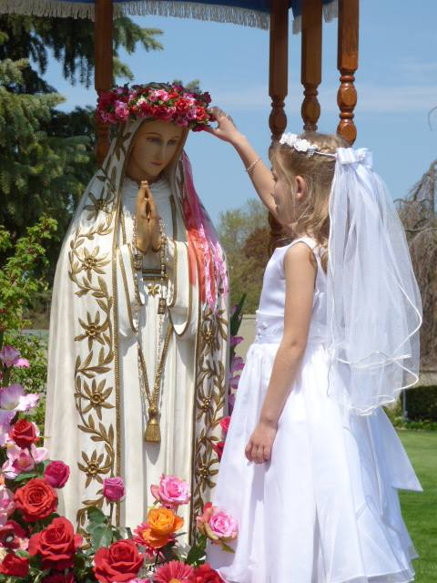 | Presider: Archbishop Jerome Listecki Assisted by: Fr. Tim Kitzke, Fr. James Lobacz  The event will include:  - Exposition of the Blessed Sacrament  - Crowning of Our Lady’s statue by First Communicants  - Rosary and hymns  - Benediction of the Blessed Sacrament

This is an outdoor event – please bring a lawn chair to sit on.
Please wear masks and practice social distancing.

Spend Mother’s Day with the Blessed Mother

First Communicants are encouraged to wear First Communion attire!

In case of rain, go to St. Vincent Pallotti – West 201 N. 76th St.

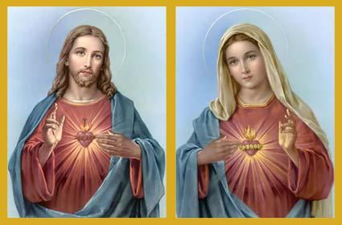
Our 41st Annual
Walk With Jesus and Mary

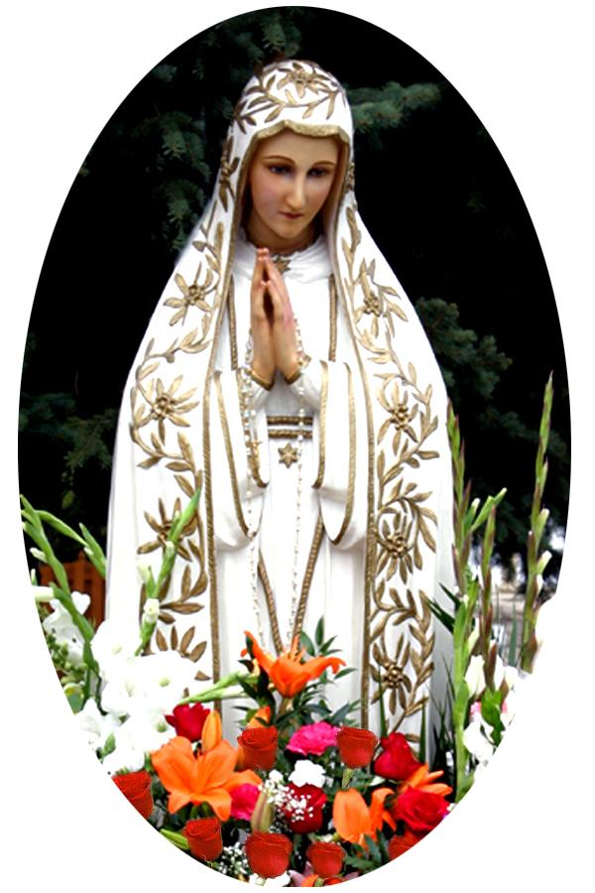 | Sponsored by Roses for Our Lady  For further information call  Roses for Our Lady President  Kevin Ricard at 414-571-9378  or email at rosesforourladymilwaukee@gmail.com  www.rosesforourlady.org

