Celebrate the
Nativity of the Blessed Mother
with Roses for Our Lady
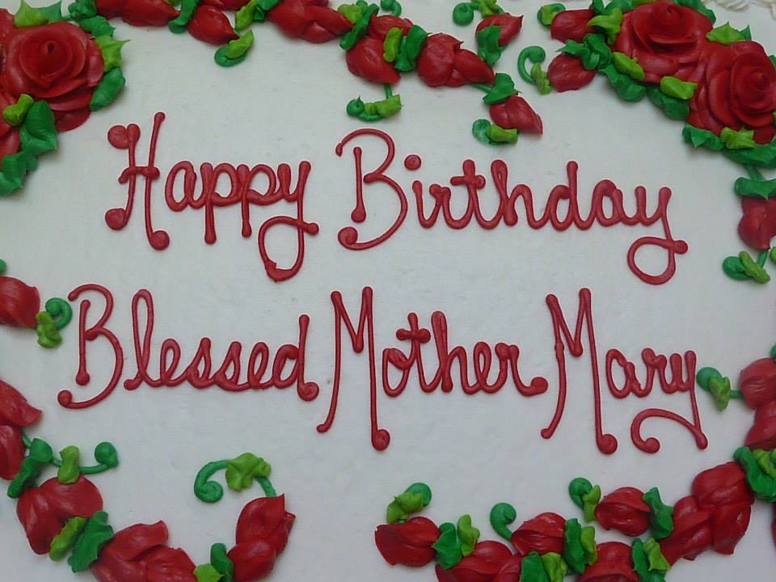 | 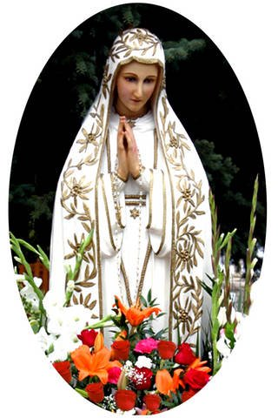
Sunday, September 9, 2018
2:00 pm
Fr. Luke Strand presiding
Saint Francis de Sales Seminary
3257 S. Lake Drive, St. Francis

A birthday party with cake and beverages will follow our monthly Holy Hour.
Please bring a non-perishable food item for donation to a local food pantry as a birthday gift for Our Lady.

www.rosesforourlady.org

