Celebrate the
Nativity of the Blessed Mother
with Roses for Our Lady
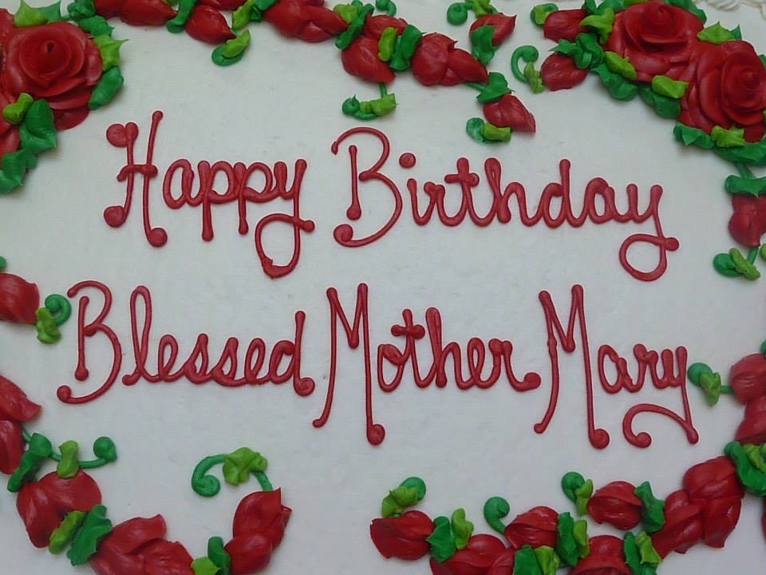 | 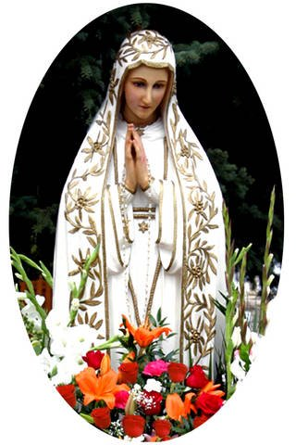
This special Holy Hour will include an
outdoor Eucharistic Rosary Procession.
Sunday, September 11th, 2 pm
Fr. James Kubicki, SJ, presiding
Saint Francis de Sales Seminary
3257 S. Lake Drive, St. Francis
A birthday party with cake and beverages will follow.
Please bring a non-perishable food item for donation to a local food pantry as a birthday gift for Our Lady.
www.rosesforourlady.org

