May Crowning Celebration

Sunday, May 8th, 2022 (Mother’s Day)
2:00 pm
Archdiocesan Marian Shrine
141 N. 68th St. Milwaukee, WI 53213
68th & Stevenson (just north of I-94)

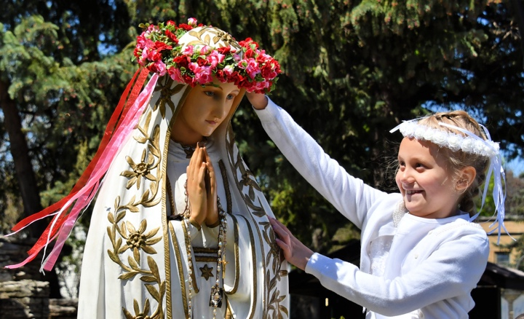 | Presider: Bishop Donald Hying (Diocese of Madison)  Assisted by: Fr. Tim Kitzke and other clergy  The event will include:  - Exposition of the Blessed Sacrament  - Crowning of Our Lady’s statue by First Communicants  - Street procession with rosary and hymns  - Benediction of the Blessed Sacrament

This is an outdoor event – please bring a lawn chair to sit on.

Spend Mother’s Day with the Blessed Mother

All First Communicants are encouraged to wear First Communion attire!

In case of rain, go to St. Vincent Pallotti – West 201 N. 76th St.

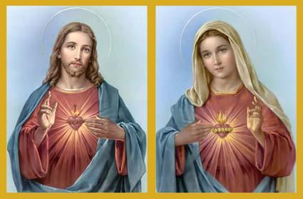
Our 42nd Annual
Walk With Jesus and Mary

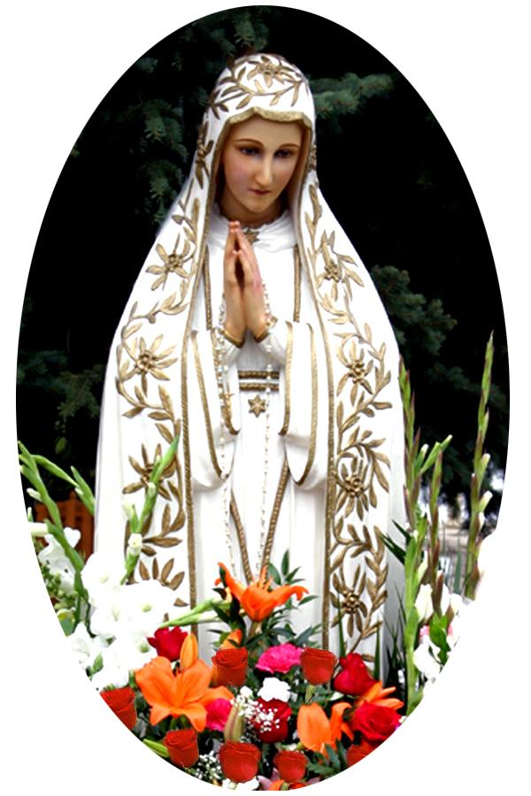 | Sponsored by Roses for Our Lady  For further information call  Roses for Our Lady President  Kevin Ricard at 414-571-9378  or email at rosesforourladymilwaukee@gmail.com  www.rosesforourlady.org

