May Crowning Celebration

**Sunday, May 12th, 2019 (Mother’s Day)**

**2:00 pm**

**Archdiocesan Marian Shrine**

68th & Stevenson (just north of I-94)

|  |  |
| --- | --- |
| http://www.rosesforourlady.org/uploads/6/1/6/3/6163495/2387160_orig.jpg | Presiders include:  **Fr. Timothy Kitzke, Fr. Enrique Hernandez**  The event will include:       * Exposition of the Blessed Sacrament * Crowning of Our Lady’s statue * Eucharistic procession with rosary and hymns * Benediction of the Blessed Sacrament |

This is an outdoor event – please bring a lawn chair to sit on.

# Spend Mother’s Day with the Blessed Mother

**First Communicants are encouraged to wear First Communion attire!**

In case of rain, go to St. Vincent Pallotti – West 201 N. 76th St.

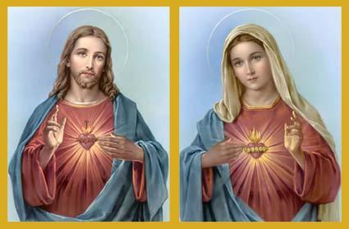

**Our 39th Annual**

**Walk With Jesus and Mary**

|  |  |
| --- | --- |
|  | Sponsored by ***Roses for Our Lady***  For further information call  Roses for Our Lady President  Kevin Ricard at 414-571-9378  or email at [rosesforourladymilwaukee@gmail.com](mailto:rosesforourladymilwaukee@gmail.com)  [**www.rosesforourlady.org**](http://www.rosesforourlady.org) |