May Crowning Celebration

Sunday, May 14th, 2017 (Mother’s Day)
2:00 pm
Archdiocesan Marian Shrine
68th & Stevenson (just north of I-94)
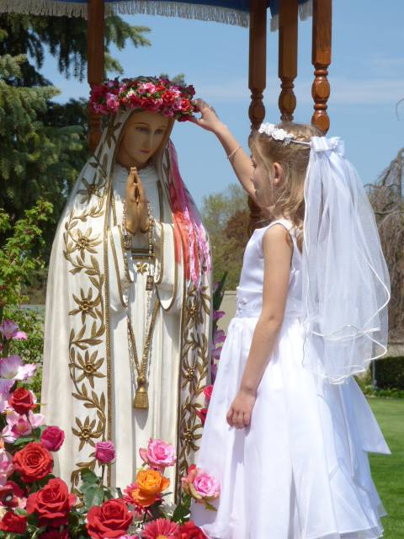 | Roses for Our Lady’s Spiritual Advisor  Fr. Timothy Kitzke, presider and homilist  The event will include:  - Exposition of the Blessed Sacrament  - May Crowning of Our Lady’s statue  - Eucharistic procession with rosary and hymns  - Benediction of the Blessed Sacrament

This is an outdoor event – please bring a lawn chair to sit on.

Spend Mother’s Day with the Blessed Mother

First Communicants are encouraged to wear First Communion attire!

In case of rain, go to St. Vincent Pallotti – West 201 N. 76th St.

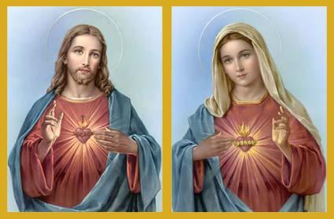
Our 37th Annual
Walk With Jesus and Mary

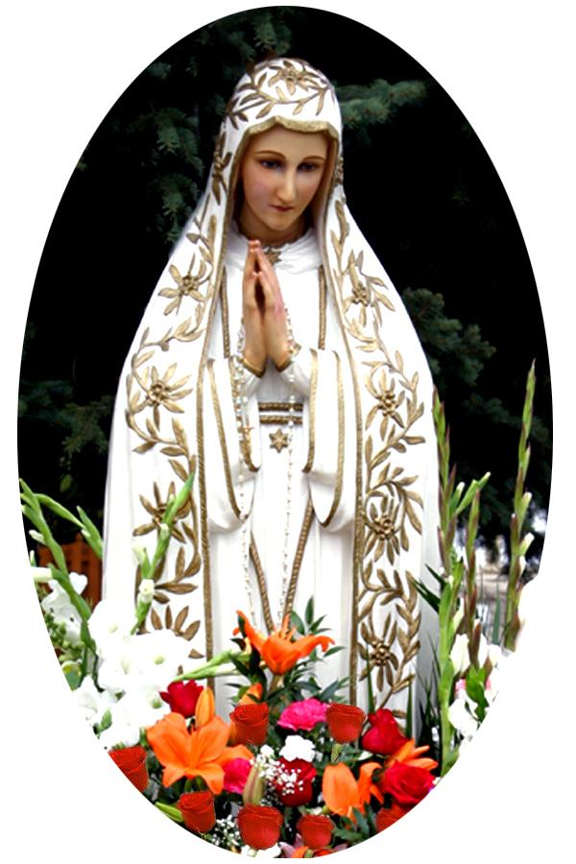 | Sponsored by Roses for Our Lady  For further information call  Roses for Our Lady President  Kevin Ricard at 414-571-9378  or email at rosesforourladymilwaukee@gmail.com  www.rosesforourlady.org

